**DVS Technologies Aws & Devops**

**1.Availability Zones**

https://www.infrastructure.aws/https://www.infrastructure.aws/

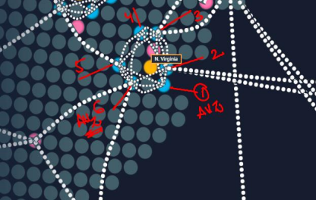

**2. Working with EC2**

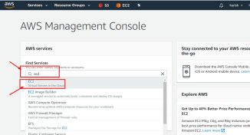

DVS Technologies, Opp Home Town, Beside Biryani Zone, Marathahalli, Bangalore Phone: 9632558585 Mobile: 8892499499 Mail : dvs.training@gmail.com Web: www.dvstechnologies.in

**DVS Technologies Aws & Devops 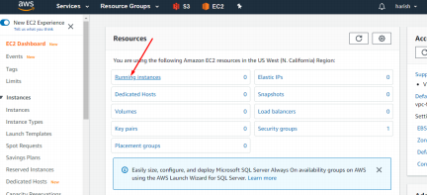Mmmmk qq mn. N**

***K*o OK**

DVk dd ewrkkmlljmS Technologies, Opp Home Town, Beside Biryani Zone, Marathahalli, Bangalore k**m**m**mmht**: 9632558585 Mobile: 8892499499 Mail : dvs.training@gmail.com Web: www.dvstechnologies.in

**D.S lTechnologies AWS & Devops 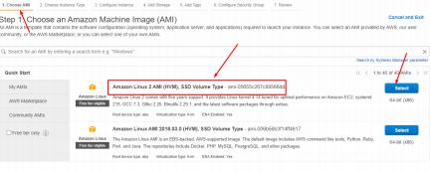**https:// aws.amazon.com/ec2/instance-types/

**Types of EC2 hardware :**

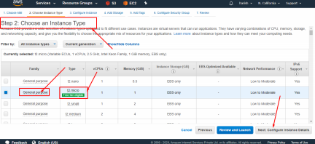

**,**. 0 kkk

**P lmmtekk *kkl***Technologiesl, Opp Home Town, Beside Biryani Zone, Marathahalli, Bangalore Phone: 9632558585 Mobile: 8892499499 Mail : dvs.training@gmail.com Web: www.dvstechnologies.in

**DVS Technologies Aws & Devops** 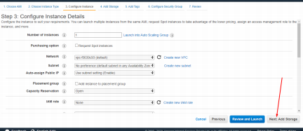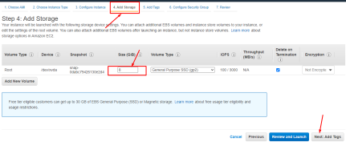

DVS Technologies, Opp Home Town, Beside Biryani Zone, Marathahalli, Bangalore Phone: 9632558585 Mobile: 8892499499 Mail : dvs.training@gmail.com Web: www.dvstechnologies.in

**DVS Technologies Aws & Devops** 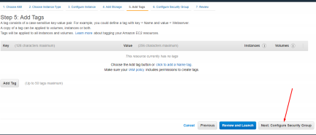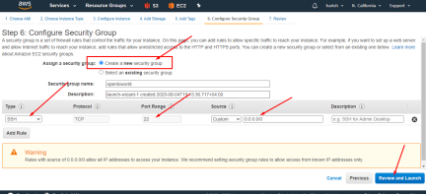

DVS Technologies, Opp Home Town, Beside Biryani Zone, Marathahalli, Bangalore Phone: 9632558585 Mobile: 8892499499 Mail : dvs.training@gmail.com Web: www.dvstechnologies.in

**DVS Technologies Aws & Devops** 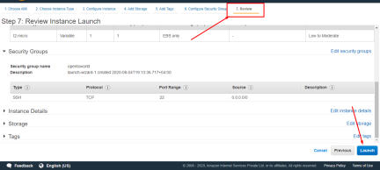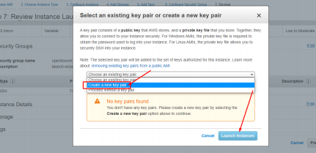

DVS Technologies, Opp Home Town, Beside Biryani Zone, Marathahalli, Bangalore Phone: 9632558585 Mobile: 8892499499 Mail : dvs.training@gmail.com Web: www.dvstechnologies.in

**DVS Technologies Aws & Devops** 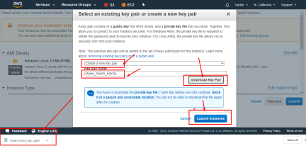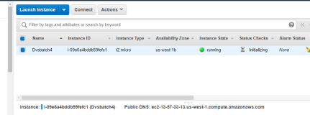

**3. Logging in to EC2**

**Download below packages from putty.org 1. Putty**

**2. Puttygen**

**3. Pageant**

DVS Technologies, Opp Home Town, Beside Biryani Zone, Marathahalli, Bangalore Phone: 9632558585 Mobile: 8892499499 Mail : dvs.training@gmail.com Web: www.dvstechnologies.in

**DVS Technologies Aws & Devops** 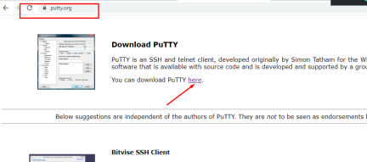

DVS Technologies, Opp Home Town, Beside Biryani Zone, Marathahalli, Bangalore Phone: 9632558585 Mobile: 8892499499 Mail : dvs.training@gmail.com Web: www.dvstechnologies.in

**DVS Technologies Aws & Devops **

DVS Technologies, Opp Home Town, Beside Biryani Zone, Marathahalli, Bangalore Phone: 9632558585 Mobile: 8892499499 Mail : dvs.training@gmail.com Web: www.dvstechnologies.in

**DVS Technologies Aws & Devops **

DVS Technologies, Opp Home Town, Beside Biryani Zone, Marathahalli, Bangalore Phone: 9632558585 Mobile: 8892499499 Mail : dvs.training@gmail.com Web: www.dvstechnologies.in

**DVS Technologies Aws & Devops **

DVS Technologies, Opp Home Town, Beside Biryani Zone, Marathahalli, Bangalore Phone: 9632558585 Mobile: 8892499499 Mail : dvs.training@gmail.com Web: www.dvstechnologies.in

**DVS Technologies Aws & Devops **

DVS Technologies, Opp Home Town, Beside Biryani Zone, Marathahalli, Bangalore Phone: 9632558585 Mobile: 8892499499 Mail : dvs.training@gmail.com Web: www.dvstechnologies.in

**DVS Technologies Aws & Devops **



DVS Technologies, Opp Home Town, Beside Biryani Zone, Marathahalli, Bangalore Phone: 9632558585 Mobile: 8892499499 Mail : dvs.training@gmail.com Web: www.dvstechnologies.in

**DVS Technologies Aws & Devops **

DVS Technologies, Opp Home Town, Beside Biryani Zone, Marathahalli, Bangalore Phone: 9632558585 Mobile: 8892499499 Mail : dvs.training@gmail.com Web: www.dvstechnologies.in

**DVS Technologies Aws & Devops **

**4. Accidental termination ec2: How to avoid accidental termination of ec2**

DVS Technologies, Opp Home Town, Beside Biryani Zone, Marathahalli, Bangalore Phone: 9632558585 Mobile: 8892499499 Mail : dvs.training@gmail.com Web: www.dvstechnologies.in

**DVS Technologies Aws & Devops **

DVS Technologies, Opp Home Town, Beside Biryani Zone, Marathahalli, Bangalore Phone: 9632558585 Mobile: 8892499499 Mail : dvs.training@gmail.com Web: www.dvstechnologies.in

**DVS Technologies Aws & Devops ==**



DVS Technologies, Opp Home Town, Beside Biryani Zone, Marathahalli, Bangalore Phone: 9632558585 Mobile: 8892499499 Mail : dvs.training@gmail.com Web: www.dvstechnologies.in

**DVS Technologies Aws & Devops **

DVS Technologies, Opp Home Town, Beside Biryani Zone, Marathahalli, Bangalore Phone: 9632558585 Mobile: 8892499499 Mail : dvs.training@gmail.com Web: www.dvstechnologies.in

**DVS Technologies Aws & Devops **

DVS Technologies, Opp Home Town, Beside Biryani Zone, Marathahalli, Bangalore Phone: 9632558585 Mobile: 8892499499 Mail : dvs.training@gmail.com Web: www.dvstechnologies.in

**DVS Technologies Aws & Devops **

**Verification:**

DVS Technologies, Opp Home Town, Beside Biryani Zone, Marathahalli, Bangalore Phone: 9632558585 Mobile: 8892499499 Mail : dvs.training@gmail.com Web: www.dvstechnologies.in

**DVS Technologies Aws & Devops **

**Changing the termination protection:**

DVS Technologies, Opp Home Town, Beside Biryani Zone, Marathahalli, Bangalore Phone: 9632558585 Mobile: 8892499499 Mail : dvs.training@gmail.com Web: www.dvstechnologies.in

**DVS Technologies Aws & Devops **

**5. BootStrap -- UserData**

DVS Technologies, Opp Home Town, Beside Biryani Zone, Marathahalli, Bangalore Phone: 9632558585 Mobile: 8892499499 Mail : dvs.training@gmail.com Web: www.dvstechnologies.in

**DVS Technologies Aws & Devops **

DVS Technologies, Opp Home Town, Beside Biryani Zone, Marathahalli, Bangalore Phone: 9632558585 Mobile: 8892499499 Mail : dvs.training@gmail.com Web: www.dvstechnologies.in

**DVS Technologies Aws & Devops **



Enable httpd port at security group level



DVS Technologies, Opp Home Town, Beside Biryani Zone, Marathahalli, Bangalore Phone: 9632558585 Mobile: 8892499499 Mail : dvs.training@gmail.com Web: www.dvstechnologies.in

**DVS Technologies Aws & Devops **

DVS Technologies, Opp Home Town, Beside Biryani Zone, Marathahalli, Bangalore Phone: 9632558585 Mobile: 8892499499 Mail : dvs.training@gmail.com Web: www.dvstechnologies.in

**DVS Technologies Aws & Devops **

DVS Technologies, Opp Home Town, Beside Biryani Zone, Marathahalli, Bangalore Phone: 9632558585 Mobile: 8892499499 Mail : dvs.training@gmail.com Web: www.dvstechnologies.in

**DVS Technologies Aws & Devops **

**USERDATA:**

DVS Technologies, Opp Home Town, Beside Biryani Zone, Marathahalli, Bangalore Phone: 9632558585 Mobile: 8892499499 Mail : dvs.training@gmail.com Web: www.dvstechnologies.in

**DVS Technologies Aws & Devops **

DVS Technologies, Opp Home Town, Beside Biryani Zone, Marathahalli, Bangalore Phone: 9632558585 Mobile: 8892499499 Mail : dvs.training@gmail.com Web: www.dvstechnologies.in

**DVS Technologies Aws & Devops **

DVS Technologies, Opp Home Town, Beside Biryani Zone, Marathahalli, Bangalore Phone: 9632558585 Mobile: 8892499499 Mail : dvs.training@gmail.com Web: www.dvstechnologies.in

**DVS Technologies Aws & Devops **

**Verification:**



DVS Technologies, Opp Home Town, Beside Biryani Zone, Marathahalli, Bangalore Phone: 9632558585 Mobile: 8892499499 Mail : dvs.training@gmail.com Web: www.dvstechnologies.in

**DVS Technologies Aws & Devops **

**6. Working with EBS**



DVS Technologies, Opp Home Town, Beside Biryani Zone, Marathahalli, Bangalore Phone: 9632558585 Mobile: 8892499499 Mail : dvs.training@gmail.com Web: www.dvstechnologies.in

**DVS Technologies Aws & Devops **

**From Console:**



DVS Technologies, Opp Home Town, Beside Biryani Zone, Marathahalli, Bangalore Phone: 9632558585 Mobile: 8892499499 Mail : dvs.training@gmail.com Web: www.dvstechnologies.in

**DVS Technologies Aws & Devops **DVS Technologies, Opp Home Town, Beside Biryani Zone, Marathahalli, Bangalore Phone: 9632558585 Mobile: 8892499499 Mail : dvs.training@gmail.com Web: www.dvstechnologies.in

**DVS Technologies Aws & Devops **

DVS Technologies, Opp Home Town, Beside Biryani Zone, Marathahalli, Bangalore Phone: 9632558585 Mobile: 8892499499 Mail : dvs.training@gmail.com Web: www.dvstechnologies.in

**DVS Technologies Aws & Devops **

DVS Technologies, Opp Home Town, Beside Biryani Zone, Marathahalli, Bangalore Phone: 9632558585 Mobile: 8892499499 Mail : dvs.training@gmail.com Web: www.dvstechnologies.in

**DVS Technologies Aws & Devops **

DVS Technologies, Opp Home Town, Beside Biryani Zone, Marathahalli, Bangalore Phone: 9632558585 Mobile: 8892499499 Mail : dvs.training@gmail.com Web: www.dvstechnologies.in

**DVS Technologies Aws & Devops **

**Increasing Volume Size:**

DVS Technologies, Opp Home Town, Beside Biryani Zone, Marathahalli, Bangalore Phone: 9632558585 Mobile: 8892499499 Mail : dvs.training@gmail.com Web: www.dvstechnologies.in

**DVS Technologies Aws & Devops **

DVS Technologies, Opp Home Town, Beside Biryani Zone, Marathahalli, Bangalore Phone: 9632558585 Mobile: 8892499499 Mail : dvs.training@gmail.com Web: www.dvstechnologies.in

**DVS Technologies Aws & Devops **

**7. Attaching EBS from one ec2 to other**

**1. Make sure that you are creating one server called SERVER1**

DVS Technologies, Opp Home Town, Beside Biryani Zone, Marathahalli, Bangalore Phone: 9632558585 Mobile: 8892499499 Mail : dvs.training@gmail.com Web: www.dvstechnologies.in

**DVS Technologies Aws & Devops **

DVS Technologies, Opp Home Town, Beside Biryani Zone, Marathahalli, Bangalore Phone: 9632558585 Mobile: 8892499499 Mail : dvs.training@gmail.com Web: www.dvstechnologies.in

**DVS Technologies Aws & Devops **

DVS Technologies, Opp Home Town, Beside Biryani Zone, Marathahalli, Bangalore Phone: 9632558585 Mobile: 8892499499 Mail : dvs.training@gmail.com Web: www.dvstechnologies.in

**DVS Technologies Aws & Devops **

**Let's write some data to the disk:**

DVS Technologies, Opp Home Town, Beside Biryani Zone, Marathahalli, Bangalore Phone: 9632558585 Mobile: 8892499499 Mail : dvs.training@gmail.com Web: www.dvstechnologies.in

**DVS Technologies Aws & Devops **

DVS Technologies, Opp Home Town, Beside Biryani Zone, Marathahalli, Bangalore Phone: 9632558585 Mobile: 8892499499 Mail : dvs.training@gmail.com Web: www.dvstechnologies.in

**DVS Technologies Aws & Devops **

DVS Technologies, Opp Home Town, Beside Biryani Zone, Marathahalli, Bangalore Phone: 9632558585 Mobile: 8892499499 Mail : dvs.training@gmail.com Web: www.dvstechnologies.in

**DVS Technologies Aws & Devops **

DVS Technologies, Opp Home Town, Beside Biryani Zone, Marathahalli, Bangalore Phone: 9632558585 Mobile: 8892499499 Mail : dvs.training@gmail.com Web: www.dvstechnologies.in

**DVS Technologies Aws & Devops**

**Make sure that you are creating SERVER2**

**Note: Create the server in same AVZ as of SERVER1 check the below picture**



DVS Technologies, Opp Home Town, Beside Biryani Zone, Marathahalli, Bangalore Phone: 9632558585 Mobile: 8892499499 Mail : dvs.training@gmail.com Web: www.dvstechnologies.in

**DVS Technologies Aws & Devops **

DVS Technologies, Opp Home Town, Beside Biryani Zone, Marathahalli, Bangalore Phone: 9632558585 Mobile: 8892499499 Mail : dvs.training@gmail.com Web: www.dvstechnologies.in

**DVS Technologies Aws & Devops **

DVS Technologies, Opp Home Town, Beside Biryani Zone, Marathahalli, Bangalore Phone: 9632558585 Mobile: 8892499499 Mail : dvs.training@gmail.com Web: www.dvstechnologies.in

**DVS Technologies Aws & Devops **

**8. Migrating EBS across AVZ's**

**1. Make sure that you are creating one EC2 server with name "SERVER1"**



DVS Technologies, Opp Home Town, Beside Biryani Zone, Marathahalli, Bangalore Phone: 9632558585 Mobile: 8892499499 Mail : dvs.training@gmail.com Web: www.dvstechnologies.in

**DVS Technologies Aws & Devops 2. Verifying disk details**

**3.Make sure that you are having EBS volume of 5GB and attach it to the SERVER1**



DVS Technologies, Opp Home Town, Beside Biryani Zone, Marathahalli, Bangalore Phone: 9632558585 Mobile: 8892499499 Mail : dvs.training@gmail.com Web: www.dvstechnologies.in

**DVS Technologies Aws & Devops**

**4. Post attaching disk Verify the disk details in the SERVER1 **

**5. Writing some data to the disk**



DVS Technologies, Opp Home Town, Beside Biryani Zone, Marathahalli, Bangalore Phone: 9632558585 Mobile: 8892499499 Mail : dvs.training@gmail.com Web: www.dvstechnologies.in

**DVS Technologies Aws & Devops**

**6. Let's create our SERVER2 in other AVZ**



DVS Technologies, Opp Home Town, Beside Biryani Zone, Marathahalli, Bangalore Phone: 9632558585 Mobile: 8892499499 Mail : dvs.training@gmail.com Web: www.dvstechnologies.in

**DVS Technologies Aws & Devops**

**7. Umount the ebs from SERVER1 and from console 8. Take snapshot**



DVS Technologies, Opp Home Town, Beside Biryani Zone, Marathahalli, Bangalore Phone: 9632558585 Mobile: 8892499499 Mail : dvs.training@gmail.com Web: www.dvstechnologies.in

**DVS Technologies Aws & Devops **

DVS Technologies, Opp Home Town, Beside Biryani Zone, Marathahalli, Bangalore Phone: 9632558585 Mobile: 8892499499 Mail : dvs.training@gmail.com Web: www.dvstechnologies.in

**DVS Technologies Aws & Devops **

DVS Technologies, Opp Home Town, Beside Biryani Zone, Marathahalli, Bangalore Phone: 9632558585 Mobile: 8892499499 Mail : dvs.training@gmail.com Web: www.dvstechnologies.in

**DVS Technologies Aws & Devops 9. Attach the volume**



DVS Technologies, Opp Home Town, Beside Biryani Zone, Marathahalli, Bangalore Phone: 9632558585 Mobile: 8892499499 Mail : dvs.training@gmail.com Web: www.dvstechnologies.in

**DVS Technologies Aws & Devops **

DVS Technologies, Opp Home Town, Beside Biryani Zone, Marathahalli, Bangalore Phone: 9632558585 Mobile: 8892499499 Mail : dvs.training@gmail.com Web: www.dvstechnologies.in

**DVS Technologies Aws & Devops 10. Login to the server2**

**9. Migrating EBS across Regions**

**Importing my old pub key to new region**



DVS Technologies, Opp Home Town, Beside Biryani Zone, Marathahalli, Bangalore Phone: 9632558585 Mobile: 8892499499 Mail : dvs.training@gmail.com Web: www.dvstechnologies.in

**DVS Technologies Aws & Devops **

DVS Technologies, Opp Home Town, Beside Biryani Zone, Marathahalli, Bangalore Phone: 9632558585 Mobile: 8892499499 Mail : dvs.training@gmail.com Web: www.dvstechnologies.in

**DVS Technologies Aws & Devops **

**NOTE: "ASSUMING WE HAVE A SNAPSHOT IN N.California and we are trying to migrate the snapshot to N.Virginia location:"**

**Create a server called "server2-Nvirg"**



DVS Technologies, Opp Home Town, Beside Biryani Zone, Marathahalli, Bangalore Phone: 9632558585 Mobile: 8892499499 Mail : dvs.training@gmail.com Web: www.dvstechnologies.in

**DVS Technologies Aws & Devops **

DVS Technologies, Opp Home Town, Beside Biryani Zone, Marathahalli, Bangalore Phone: 9632558585 Mobile: 8892499499 Mail : dvs.training@gmail.com Web: www.dvstechnologies.in

**DVS Technologies Aws & Devops **

DVS Technologies, Opp Home Town, Beside Biryani Zone, Marathahalli, Bangalore Phone: 9632558585 Mobile: 8892499499 Mail : dvs.training@gmail.com Web: www.dvstechnologies.in

**DVS Technologies Aws & Devops **

DVS Technologies, Opp Home Town, Beside Biryani Zone, Marathahalli, Bangalore Phone: 9632558585 Mobile: 8892499499 Mail : dvs.training@gmail.com Web: www.dvstechnologies.in

**DVS Technologies Aws & Devops **

DVS Technologies, Opp Home Town, Beside Biryani Zone, Marathahalli, Bangalore Phone: 9632558585 Mobile: 8892499499 Mail : dvs.training@gmail.com Web: www.dvstechnologies.in

**DVS Technologies Aws & Devops **

DVS Technologies, Opp Home Town, Beside Biryani Zone, Marathahalli, Bangalore Phone: 9632558585 Mobile: 8892499499 Mail : dvs.training@gmail.com Web: www.dvstechnologies.in

**DVS Technologies Aws & Devops **

DVS Technologies, Opp Home Town, Beside Biryani Zone, Marathahalli, Bangalore Phone: 9632558585 Mobile: 8892499499 Mail : dvs.training@gmail.com Web: www.dvstechnologies.in

**DVS Technologies Aws & Devops **

DVS Technologies, Opp Home Town, Beside Biryani Zone, Marathahalli, Bangalore Phone: 9632558585 Mobile: 8892499499 Mail : dvs.training@gmail.com Web: www.dvstechnologies.in

**DVS Technologies Aws & Devops**

**10. Metadata**



**11. Working with AMI's**

**1. Make sure that you are creating one ec2 server and name it as base server**

DVS Technologies, Opp Home Town, Beside Biryani Zone, Marathahalli, Bangalore Phone: 9632558585 Mobile: 8892499499 Mail : dvs.training@gmail.com Web: www.dvstechnologies.in

**DVS Technologies Aws & Devops **

**VERIFICATION:**

**Creating Image from the EC2:**

DVS Technologies, Opp Home Town, Beside Biryani Zone, Marathahalli, Bangalore Phone: 9632558585 Mobile: 8892499499 Mail : dvs.training@gmail.com Web: www.dvstechnologies.in

**DVS Technologies Aws & Devops **

DVS Technologies, Opp Home Town, Beside Biryani Zone, Marathahalli, Bangalore Phone: 9632558585 Mobile: 8892499499 Mail : dvs.training@gmail.com Web: www.dvstechnologies.in

**DVS Technologies Aws & Devops **

**Launching Instance from custom image:**



DVS Technologies, Opp Home Town, Beside Biryani Zone, Marathahalli, Bangalore Phone: 9632558585 Mobile: 8892499499 Mail : dvs.training@gmail.com Web: www.dvstechnologies.in

**DVS Technologies Aws & Devops **

DVS Technologies, Opp Home Town, Beside Biryani Zone, Marathahalli, Bangalore Phone: 9632558585 Mobile: 8892499499 Mail : dvs.training@gmail.com Web: www.dvstechnologies.in

**DVS Technologies Aws & Devops **

DVS Technologies, Opp Home Town, Beside Biryani Zone, Marathahalli, Bangalore Phone: 9632558585 Mobile: 8892499499 Mail : dvs.training@gmail.com Web: www.dvstechnologies.in

**DVS Technologies Aws & Devops**

**12. Migrating AMI from one region to other**

**1. Assuming that we already have customized image in N.Viriginia region I am planning to migrate the image to N.California & try to spin up the server from this customized image**

**Source --> N.Virginia**

**Dest --> N.California**



DVS Technologies, Opp Home Town, Beside Biryani Zone, Marathahalli, Bangalore Phone: 9632558585 Mobile: 8892499499 Mail : dvs.training@gmail.com Web: www.dvstechnologies.in

**DVS Technologies Aws & Devops **

DVS Technologies, Opp Home Town, Beside Biryani Zone, Marathahalli, Bangalore Phone: 9632558585 Mobile: 8892499499 Mail : dvs.training@gmail.com Web: www.dvstechnologies.in

**DVS Technologies Aws & Devops **

DVS Technologies, Opp Home Town, Beside Biryani Zone, Marathahalli, Bangalore Phone: 9632558585 Mobile: 8892499499 Mail : dvs.training@gmail.com Web: www.dvstechnologies.in

**DVS Technologies Aws & Devops **

**Launching Instance from Customized Image:**



DVS Technologies, Opp Home Town, Beside Biryani Zone, Marathahalli, Bangalore Phone: 9632558585 Mobile: 8892499499 Mail : dvs.training@gmail.com Web: www.dvstechnologies.in

**DVS Technologies Aws & Devops **

**13. Working with Elastic Ipaddress**

**Create one ec2 server & observer its public and private ipaddress**



DVS Technologies, Opp Home Town, Beside Biryani Zone, Marathahalli, Bangalore Phone: 9632558585 Mobile: 8892499499 Mail : dvs.training@gmail.com Web: www.dvstechnologies.in

**DVS Technologies Aws & Devops **

**Stop ec2 & check public ipaddress:**

DVS Technologies, Opp Home Town, Beside Biryani Zone, Marathahalli, Bangalore Phone: 9632558585 Mobile: 8892499499 Mail : dvs.training@gmail.com Web: www.dvstechnologies.in

**DVS Technologies Aws & Devops **

DVS Technologies, Opp Home Town, Beside Biryani Zone, Marathahalli, Bangalore Phone: 9632558585 Mobile: 8892499499 Mail : dvs.training@gmail.com Web: www.dvstechnologies.in